**ERA is organising the ERTMS conference - #CCRCC2019 - “The Engine for the Digital Future”**

**26Aug**2019

From 15 to 17 October 2019 in Valenciennes.

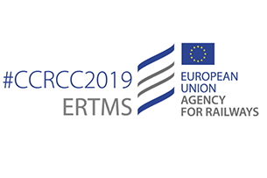

This benchmark event will gather up to 500 experts from the Railway sector, including Railway Undertakings, Infrastructure Managers, Industry Suppliers and decision makers from across the world.

While the structure of large conferences normally does not allow for detailed discussions on specific topics, the Agency has found a way to integrate this necessary component by introducing a set of workshops to be held in the afternoon of 15th October. The workshops aim to provide a platform for learning, discussion and contribution to the compelling and important issues in the field of ERTMS. [Read more](https://www.era.europa.eu/sites/default/files/events-news/docs/ccrcc_press_release_en.pdf)

Online registration is mandatory for all conference participants. Should you wish to attend the conference and contribute to the debate, please follow the [link](https://ccrcc2019.eu/).

Click [here](https://www.era.europa.eu/sites/default/files/events-news/docs/ccrcc_2019_agenda_en.pdf) to download the agenda.